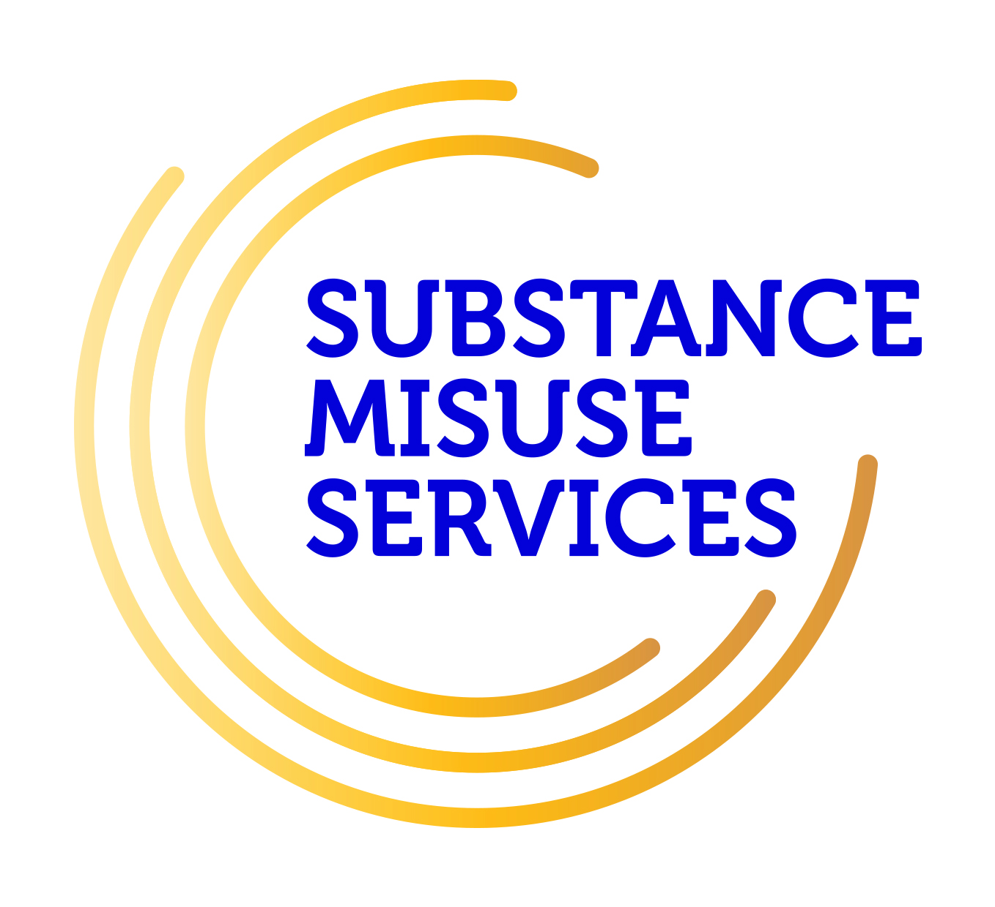
ARDÚ
Carlow/Kilkenny Substance Misuse Services
Elm Court, St Dympna’s Hospital, Athy Rd, Carlow.
Carlow: 059 9178050
Email: ardu.carlowkilkenny@hse.ie
Referral Form
Please complete all relevant sections with as much detail as possible
Client Name: |  |  | Date of Birth:
Address: |  |  | Contact Number:  Landline/Mobile
Is it okay to contact on the above address? |  |  | YES NO
Is it okay to contact on the above number? |  |  | YES NO
Has client consented to this referral? |  |  | YES NO
Parental/Guardian consent needed? (Form Attached) |  |  | YES NO
Suicide Risk |  |  | YES NO
Significant BBV -> High Risk |  |  | YES NO
Under 18 |  |  | YES NO
Reason for referral /
Details of Substance Misuse History

Has a screening been completed? |  | AUDIT: YES NO DUDIT: YES NO  CUDIT: YES NO Gambling: YES NO  If yes, has copy been forwarded with referral? YES NO
Other agencies involved with client:  YES NO |  | If yes please provide details:
Name of Client’s G.P.
Prescribed Medication:
Referrer’s Details & Contact Number:
Date of Referral

Staff Signature:
This referral is for assessment by the Substance Misuse Team to determine the required Treatment/Care Plan

